**6. Zero - Variance Features**

**Problem statement:**

Find which columns of the given dataset with zero variance, explore various techniques used to remove the zero variance from the dataset to perform certain analysis.

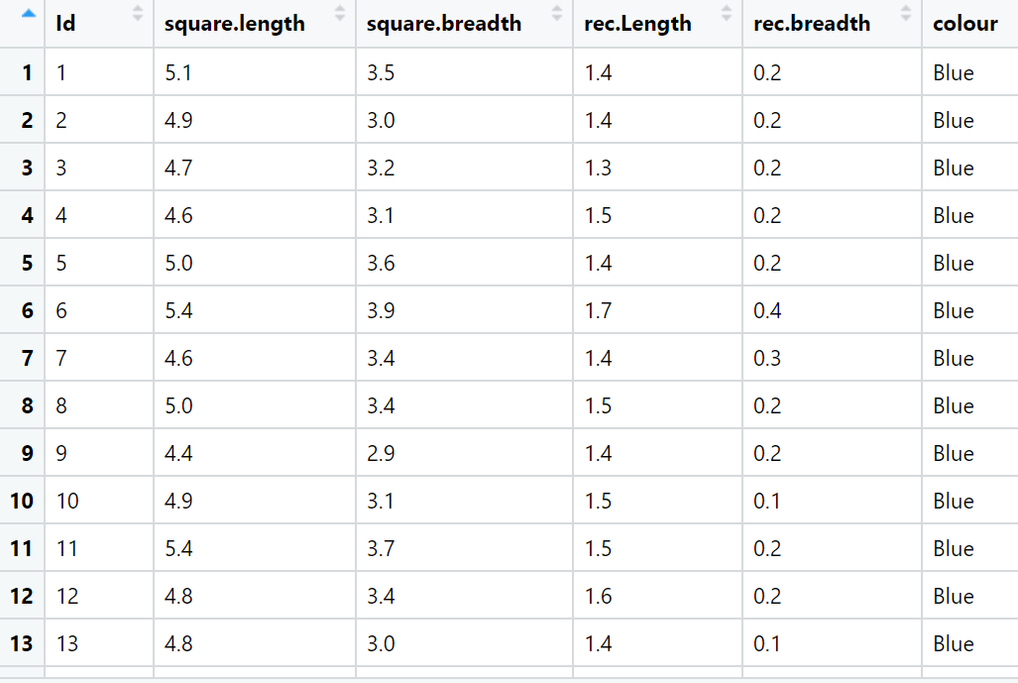

**Ans:-**

**Data types: -**

|  |  |  |  |
| --- | --- | --- | --- |
| **Name of features** | **Description** | **Type** | **Relevance** |
| square.length | square.length | Ratio | Relevant |
| square.breadth | square.breadth | Ratio | Relevant |
| rec.Length | rec.Length | Ratio | Relevant |
| rec.breadth | rec.breadth | Ratio | Relevant |
| colour | colour | Nominal | Relevant |